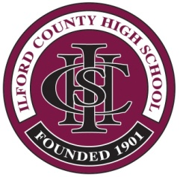
Ilford County High School

Summer 2020 – A Level Post Results Services
Form D: Appeal on the basis of my Mock Examination Result

Please use a Separate Form for Each Subject

Candidate Name: .......................................................................................................................
(Print Name – Use Capital Letters)

Candidate Number: ......................................... Date of Birth: ...............................................

Examination Board | Subject | Module / Unit Description

I wish to express an interest in making an appeal on the basis of my Mock Examination Result. My appeal is detailed below and the evidence is attached. I understand that the grounds on which an appeal can be made have not yet been published.

Supporting Evidence (All evidence must be attached to this form or it will not be considered)

Candidate Signature: ……………………………………...…………. Date: …………………...........

Parent Signature: …………………………………………………… Date: …………………...……….

COMPLETED FORM to be with the Examinations Office by:
Thursday 10th September 2020 to allow for investigation to be completed before the Ofqual deadline of 17th September 2020

Completed forms can be sent by email to:
examinations@ichs.org.uk

